Shape-Forming Rearrangement

Definition
# Source: AI Source: Provided by: [Data Path: Persons Table -> ID Column: 1, Name_En Column: Motasem Essam] -> From: [ChatGPT] on [7/25/2026]
Shape-Forming Rearrangement is a type of geometric figure rearrangement in which two or more geometric pieces are reorganized to create a specific target shape, such as a rectangle, square, triangle, parallelogram, or another polygon.
The pieces may be translated, rotated, reflected, or reordered as needed. The goal is to obtain the required overall shape while preserving the shape and size of each piece.

Simple Definition
# Source: AI Source: Provided by: [Data Path: Persons Table -> ID Column: 1, Name_En Column: Motasem Essam] -> From: [ChatGPT] on [7/25/2026]
Shape-forming rearrangement means rearranging geometric pieces to create a desired final shape.

Example
# Source: AI Source: Provided by: [Data Path: Persons Table -> ID Column: 1, Name_En Column: Motasem Essam] -> From: [ChatGPT] on [7/25/2026]
An L-shaped region is divided into smaller rectangular pieces. These pieces are rearranged to form one complete rectangle.
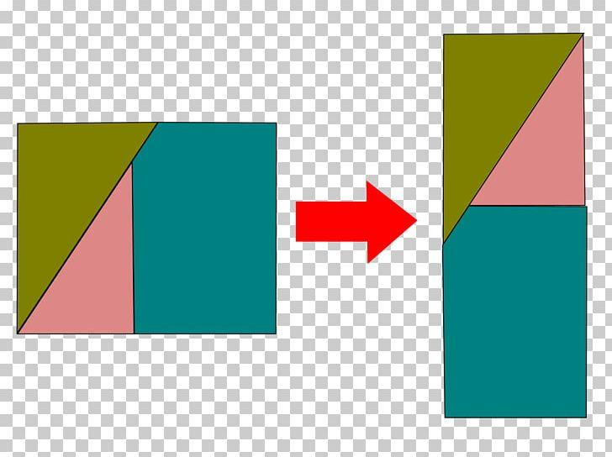

Main Classification of Shape-Forming Rearrangement
# Source: AI Source: Provided by: [Data Path: Persons Table -> ID Column: 1, Name_En Column: Motasem Essam] -> From: [ChatGPT] on [7/25/2026]
The following is a practical classification based on the target shape. These categories are descriptive and can overlap.

1. Rectangle-Forming Rearrangement
# Source: AI Source: Provided by: [Data Path: Persons Table -> ID Column: 1, Name_En Column: Motasem Essam] -> From: [ChatGPT] on [7/25/2026]
Pieces are reorganized to form a rectangle with four right angles and opposite sides equal.
Example: Several rectangular and square pieces are rearranged to form a larger rectangle without gaps or overlaps.
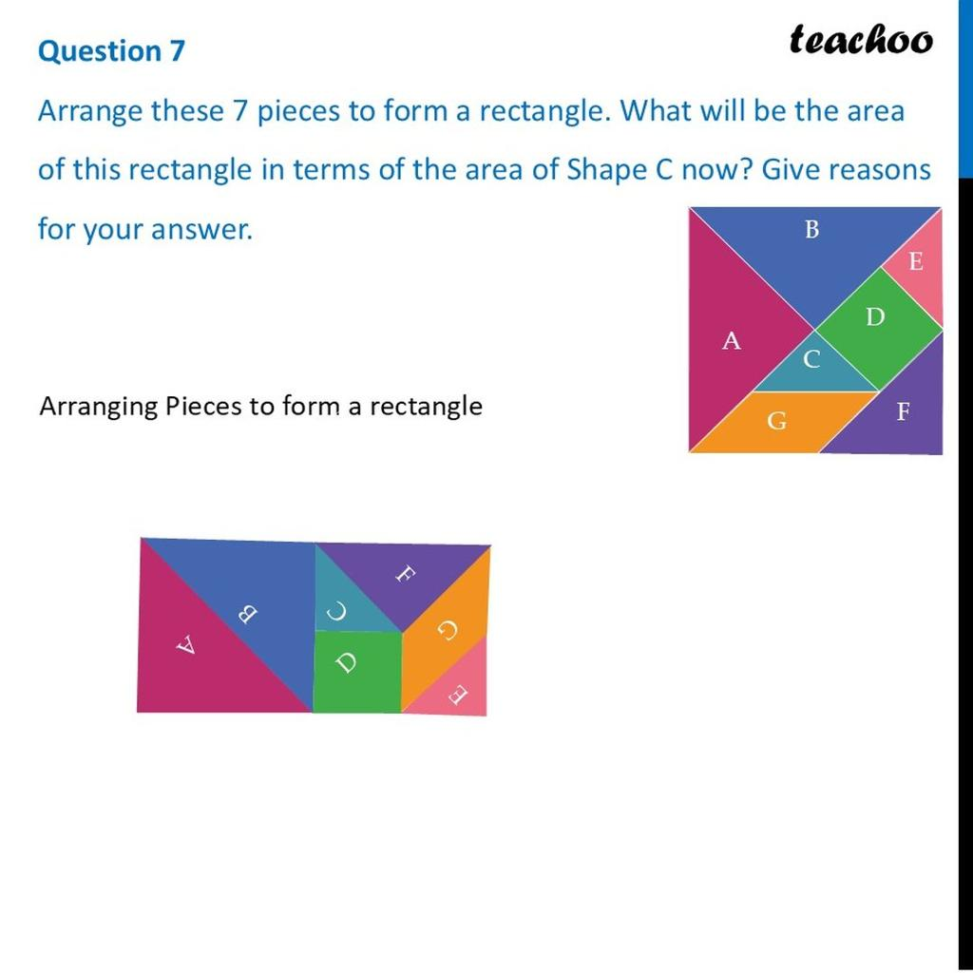

2. Square-Forming Rearrangement
# Source: AI Source: Provided by: [Data Path: Persons Table -> ID Column: 1, Name_En Column: Motasem Essam] -> From: [ChatGPT] on [7/25/2026]
Pieces are rearranged to create a square with four equal sides and four right angles.
Example: Four congruent triangular pieces are arranged around a central point to create a square-shaped outline.
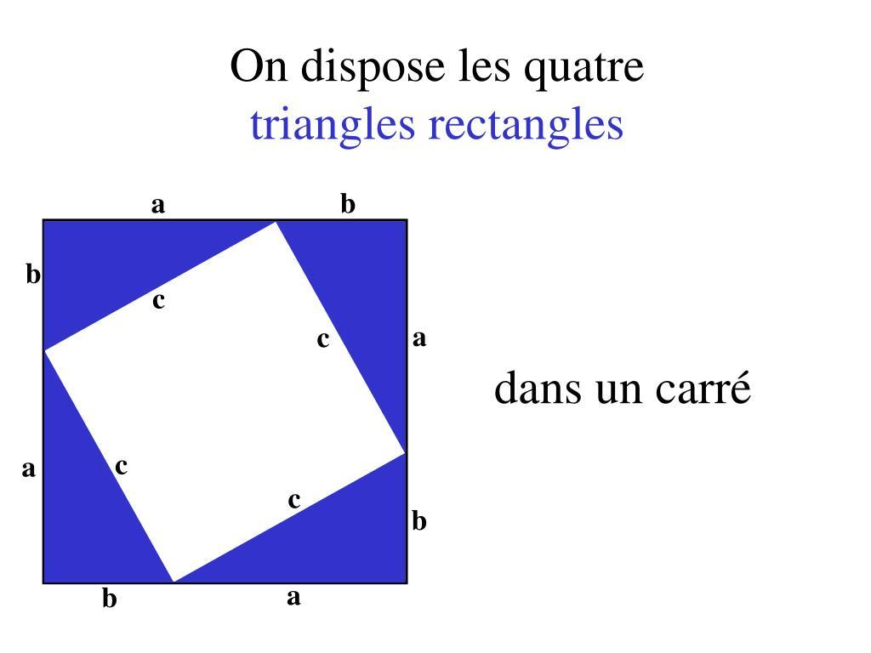

3. Triangle-Forming Rearrangement
# Source: AI Source: Provided by: [Data Path: Persons Table -> ID Column: 1, Name_En Column: Motasem Essam] -> From: [ChatGPT] on [7/25/2026]
Pieces are reorganized to form a triangular target shape.
Example: Several smaller triangular pieces are arranged to create one larger triangle.
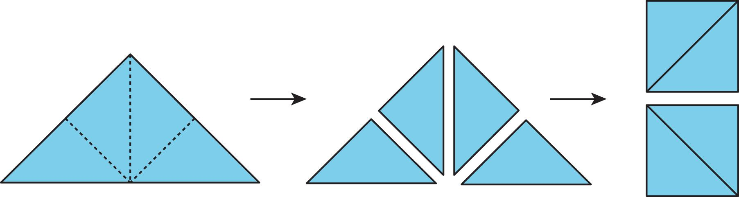

4. Parallelogram-Forming Rearrangement
# Source: AI Source: Provided by: [Data Path: Persons Table -> ID Column: 1, Name_En Column: Motasem Essam] -> From: [ChatGPT] on [7/25/2026]
Pieces are reorganized to form a parallelogram, in which both pairs of opposite sides are parallel.
Example: A triangular piece is moved from one end of a shape to the other to transform a trapezoid-like arrangement into a parallelogram.
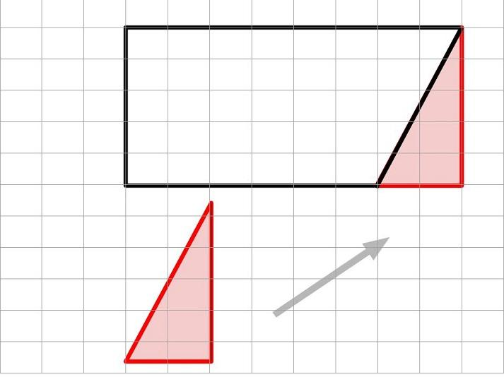

5. Trapezoid-Forming Rearrangement
# Source: AI Source: Provided by: [Data Path: Persons Table -> ID Column: 1, Name_En Column: Motasem Essam] -> From: [ChatGPT] on [7/25/2026]
Pieces are arranged to form a trapezoid, a quadrilateral with at least one pair of parallel sides under the inclusive definition.
Example: A triangle and a quadrilateral are combined to form a trapezoid with parallel top and bottom edges.
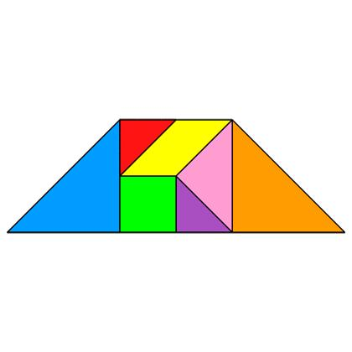

6. Rhombus-Forming Rearrangement
# Source: AI Source: Provided by: [Data Path: Persons Table -> ID Column: 1, Name_En Column: Motasem Essam] -> From: [ChatGPT] on [7/25/2026]
Pieces are rearranged to create a rhombus with four equal sides.
Example: Four triangular pieces are placed together to create a diamond-shaped rhombus.
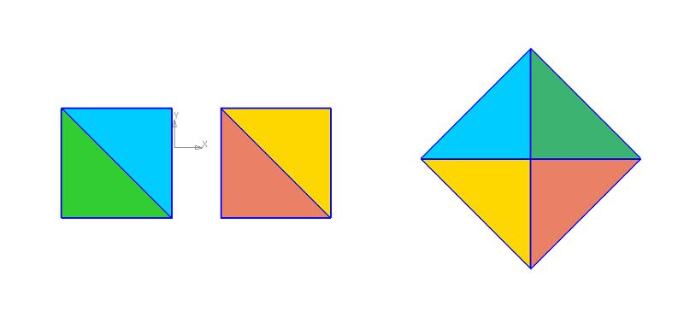

7. Regular-Polygon-Forming Rearrangement
# Source: AI Source: Provided by: [Data Path: Persons Table -> ID Column: 1, Name_En Column: Motasem Essam] -> From: [ChatGPT] on [7/25/2026]
Pieces are arranged to create a regular polygon, whose sides and interior angles are all equal.
Example: Identical triangular pieces are assembled around a common center to form a regular hexagon.
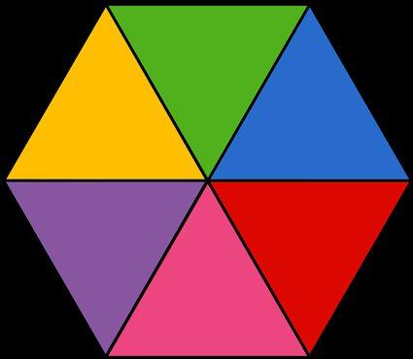

8. Composite-Shape-Forming Rearrangement
# Source: AI Source: Provided by: [Data Path: Persons Table -> ID Column: 1, Name_En Column: Motasem Essam] -> From: [ChatGPT] on [7/25/2026]
Pieces are reorganized to create a target shape made from multiple recognizable geometric parts, rather than a single basic polygon.
Example: Triangles, rectangles, and other polygonal pieces are combined to form an L-shaped or T-shaped region.
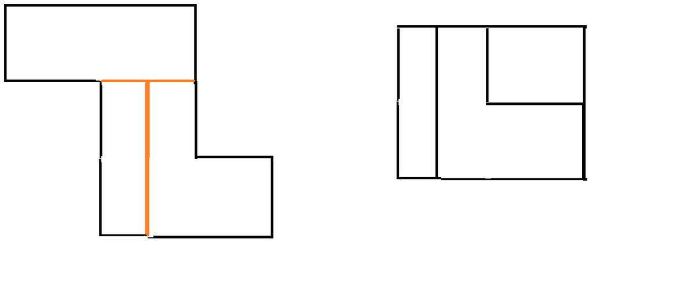

Mathematical Representation
# Source: AI Source: Provided by: [Data Path: Persons Table -> ID Column: 1, Name_En Column: Motasem Essam] -> From: [ChatGPT] on [7/25/2026]
Suppose an original region $F$ consists of several pieces:
$$F=P_{1}∪P_{2}∪⋯∪P_{n}$$
After rearrangement, the pieces form a target shape $T$:
$$T=P'_{1}∪P'_{2}∪⋯∪P'_{n}$$
If all the same pieces are used and they cover the target without gaps or overlaps, then the total area is preserved:
$$\boxed{A\left(F\right)=A\left(T\right)}$$
This principle is useful for demonstrating area relationships and solving geometric dissection problems.

Detailed Mathematical Example: L-Shape to Rectangle
# Source: AI Source: Provided by: [Data Path: Persons Table -> ID Column: 1, Name_En Column: Motasem Essam] -> From: [ChatGPT] on [7/25/2026]
Consider an L-shaped region made from two non-overlapping rectangles:
- Rectangle 1: $6×2$, with area $12$.
- Rectangle 2: $2×4$, with area $8$.
The total area is:
$$A=6\left(2\right)+2\left(4\right)=12+8=20$$
The pieces can be rearranged to form a rectangle of dimensions $5×4$, provided the pieces' actual shapes and dimensions can be tiled into that target without gaps or overlaps.
The target rectangle would have area:
$$A_{T}=5\left(4\right)=20$$
Thus, the areas agree:
$$\boxed{A\left(F\right)=A\left(T\right)=20}$$
Important: Equal areas are necessary for a rearrangement using the same pieces, but equal areas alone do not guarantee that the pieces can form the desired target shape. The pieces must also fit geometrically.

Properties of Shape-Forming Rearrangement
# Source: AI Source: Provided by: [Data Path: Persons Table -> ID Column: 1, Name_En Column: Motasem Essam] -> From: [ChatGPT] on [7/25/2026]
- Target-oriented: The arrangement is designed to produce a specified final shape.
- Piece preservation: The original pieces are retained.
- Shape and size preservation: Each piece keeps its dimensions when only rigid movements are used.
- Area preservation: The total area remains constant if no material is added or removed and the pieces do not overlap.
- Boundary change: The outer boundary may change substantially.
- Flexible transformations: Translation, rotation, reflection, and reordering may be combined.
- Geometric constraints: The pieces must fit together to produce the intended target.
- Multiple possible solutions: Different arrangements may create the same target shape.

Shape-Forming Rearrangement vs. Other Types
# Source: AI Source: Provided by: [Data Path: Persons Table -> ID Column: 1, Name_En Column: Motasem Essam] -> From: [ChatGPT] on [7/25/2026]
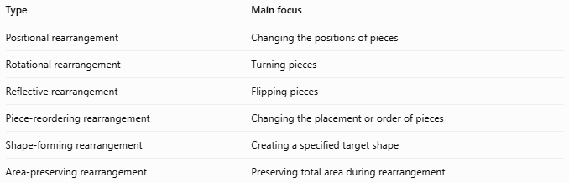
Type | Main focus
Positional rearrangement | Changing the positions of pieces
Rotational rearrangement | Turning pieces
Reflective rearrangement | Flipping pieces
Piece-reordering rearrangement | Changing the placement or order of pieces
Shape-forming rearrangement | Creating a specified target shape
Area-preserving rearrangement | Preserving total area during rearrangement
These categories can overlap. For example, forming a rectangle from an L-shaped region may involve piece reordering, rotation, and translation simultaneously.

Classification Summary
# Source: AI Source: Provided by: [Data Path: Persons Table -> ID Column: 1, Name_En Column: Motasem Essam] -> From: [ChatGPT] on [7/25/2026]
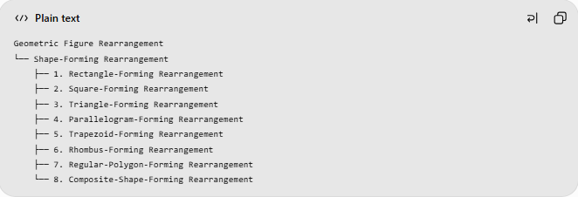
Geometric Figure Rearrangement
└── Shape-Forming Rearrangement
├── 1. Rectangle-Forming Rearrangement
├── 2. Square-Forming Rearrangement
├── 3. Triangle-Forming Rearrangement
├── 4. Parallelogram-Forming Rearrangement
├── 5. Trapezoid-Forming Rearrangement
├── 6. Rhombus-Forming Rearrangement
├── 7. Regular-Polygon-Forming Rearrangement
└── 8. Composite-Shape-Forming Rearrangement
This is a practical classification based on the intended target shape, not a universally standardized taxonomy.

Key Points
# Source: AI Source: Provided by: [Data Path: Persons Table -> ID Column: 1, Name_En Column: Motasem Essam] -> From: [ChatGPT] on [7/25/2026]
- Shape-forming rearrangement aims to create a specific geometric figure.
- The target may be a basic polygon or a composite shape.
- Pieces may be translated, rotated, reflected, or reordered.
- Area is preserved when the same pieces are rearranged without gaps or overlaps.
- Equal area alone does not prove that a particular rearrangement is possible.

Conclusion
# Source: AI Source: Provided by: [Data Path: Persons Table -> ID Column: 1, Name_En Column: Motasem Essam] -> From: [ChatGPT] on [7/25/2026]
Shape-Forming Rearrangement is a geometric method in which pieces are reorganized to produce a desired final shape. It connects geometric dissection with area preservation, polygon construction, tiling, and spatial reasoning.

